**Aim:** **Layer 2 Security.**

**Part 1: Configure Switch / Router**:

1. **Step 1: Configure secret**

Execute command on all switches and router

R1/SW(config) # **enable secret enpa55**

1. **Step 2: Configure console password**

Execute command on all switches and router

R1/SW(config)# **line console 0**

R1/SW(config-line)# **password conpa55**

R1/SW(config-line)# **login**

1. **Step 3: Configure SSH login**

Execute command on all switches and router

R1/SW(config)# **ip domain-name ccnasecurity.com**

R1/SW(config)# **username admin secret adminpa55**

R1/SW(config)# **line vty 0 4**

R1/SW(config-line)# **login local**

R1/SW(config-line)# **crypto key generate rsa**

**Part 2: Configure Root Bridge:**

1. **Step 1: Determine the current root bridge.**

Central# **show spanning-tree**

SW1# **show spanning-tree**

1. **Step 2: Assign Central as the primary root bridge.**

Central(config)# **spanning-tree vlan 1 root primary**

Central# **show spanning-tree**

1. **Step 3: Assign SW-1 as a secondary root bridge.**

SW1(config)# **spanning-tree vlan 1 root secondary**

SW1# **show spanning-tree**

**Part 3: Protect Against STP Attacks :**

1. **Step 1: Enable PortFast on all access ports**.

SWA/B(config)# **int range fa0/1 - 4**

SWA/B(config-if-range)# **spanning-tree portfast**

1. **Step 2: Enable BPDU guard on all access ports**.

SWA/B(config)# **int range fa0/1 - 4**

SWA/B(config-if-range)# **spanning-tree bpduguard enable**

1. **Step 3: Enable root guard.**

SW-1/2(config)# **int range fa0/23 - 24**

SW-1/2(config-if-range)# **spanning-tree guard root**

**Part 4: Configure Port Security and Disable Unused Ports**:

1. **Step 1: Configure basic port security on all ports connected to host devices.**

SW-A/B(config)# **int range fa0/1 - 22**

SW-A/B(config-if-range)# **switchport mode access**

SW-A/B(config-if-range)# **switchport port-security**

SW-A/B(config-if-range)# **switchport port-security maximum 2**

SW-A/B(config-if-range)# **switchport port-security violation shutdown**

SW-A/B(config-if-range)# **switchport port-security mac-address sticky**

1. **Step 2: Verify port security**.

SW-A/B# **show port-security int fa0/1**

1. **Step 3: Disable unused ports.**

SW-A/B(config)# **int range fa0/5 - 22**

SW-A/B(config-if-range)# **shutdown**

1. **Step 4: Verify Connectivity**

Ping C1->C2 (Successful)

Ping C1->D1 (Successful)

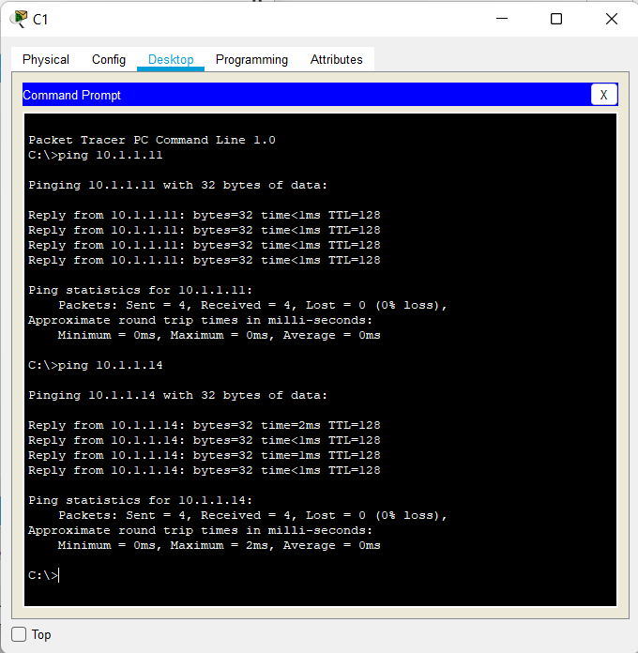

1. **Step 5: Verify port security.**

SW-A/B# **show port-security int fa0/**

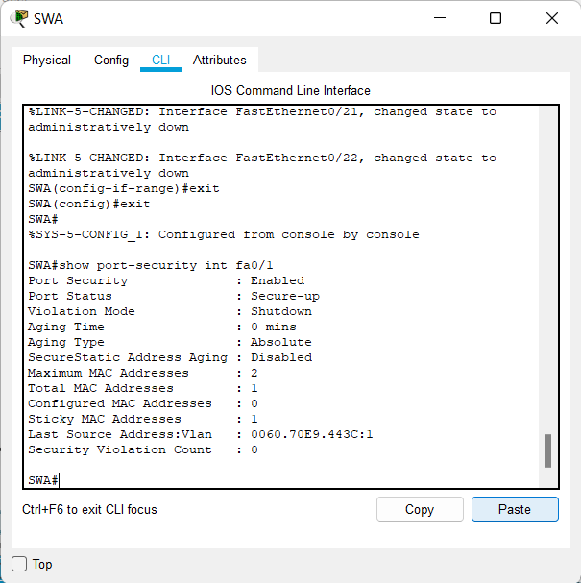

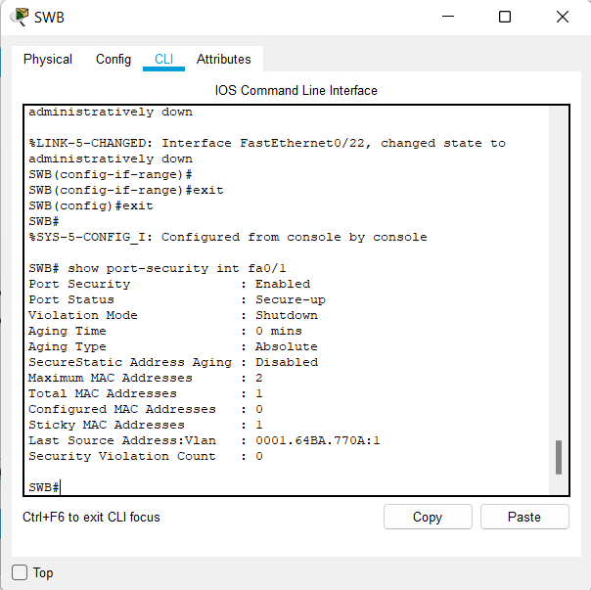

**Output:**

